In TrueNAS create your dataset.
Unzip the package to that dataset.
Folder structure should be as follows:
/mnt/{your dataset}/
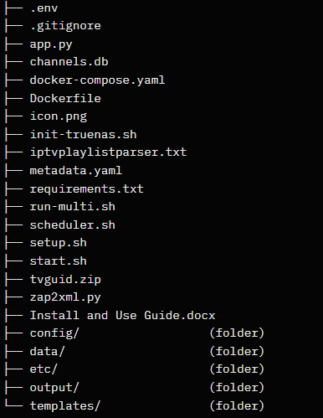
Edit the docker-compose.yaml file to use your dataset location
then just copy in the install from yaml.
Bonus: Icon
from truenas shell either from putty or in the webui
sudo nano /mnt/.ix-apps/app_configs/tvguide/metadata.yaml
Goto the end of metadata: press enter add icon: and the following url

https://upload.wikimedia.org/wikipedia/commons/thumb/e/e1/TV_Guide_Digital_logo_2019.svg/1200px-TV_Guide_Digital_logo_2019.svg.png
it will look like this when you are done.
If it doesn’t show up it will at some point

Goto the web interface at the port you specified
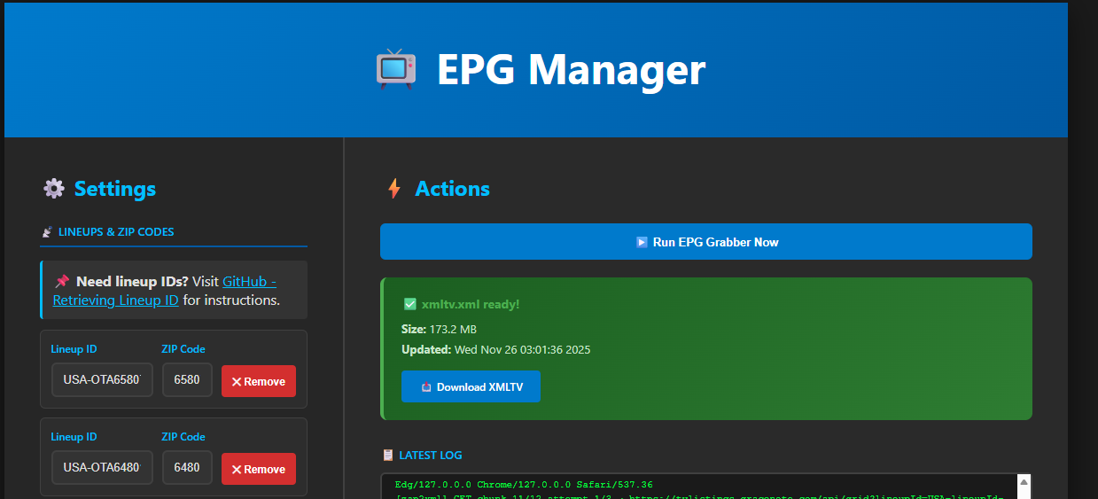
I have a lot of the lineups and zips in there for testing and examples it merges them all into one guide.
you can pull the data from IP:port/xmltv straight into whatever you need a guide in.

